[](http://www.google.com/url?sa=i&rct=j&q=delta&source=images&cd=&cad=rja&docid=vgfLPJ-GQ9moZM&tbnid=I7ZUfWDO2bDPtM:&ved=0CAUQjRw&url=http%3A%2F%2Fwww.vawnet.org%2Fspecial-collections%2FDELTA.php&ei=ZSR4UeGkForqrAH16IHgCA&bvm=bv.45580626,d.aWM&psig=AFQjCNGsIZjGcS4VCakSaMVZRSSPBhweqw&ust=1366914468881322)[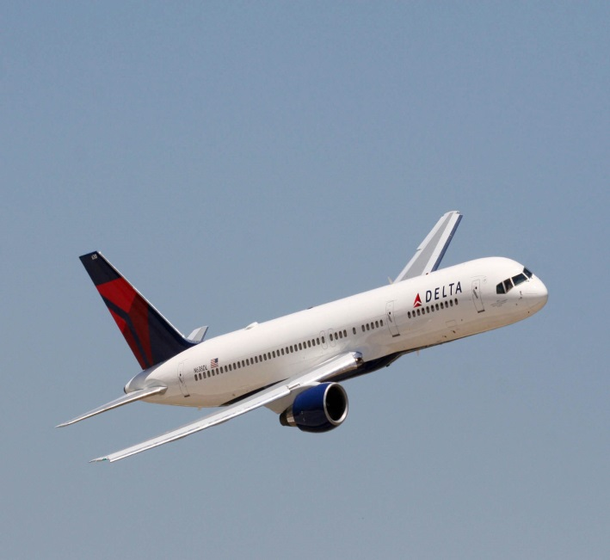](http://www.google.com/url?sa=i&rct=j&q=delta&source=images&cd=&cad=rja&docid=UXQ5X0ceoqSMkM&tbnid=wb4f5_B8HukxzM:&ved=0CAUQjRw&url=http%3A%2F%2Feverydayheroes2013.com%2Froom-reservations%2Fdelta-airlines-offical-airline-of-edh%2F&ei=giR4UaWgO8iwqQGSu4CwBQ&bvm=bv.45580626,d.aWM&psig=AFQjCNGsIZjGcS4VCakSaMVZRSSPBhweqw&ust=1366914468881322)

[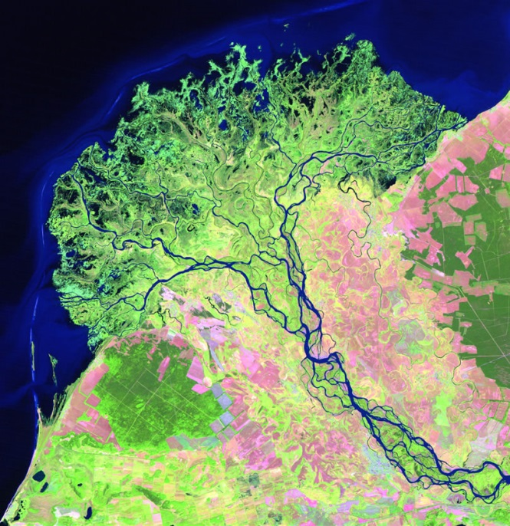](http://www.google.com/url?sa=i&rct=j&q=delta&source=images&cd=&cad=rja&docid=2M5tp5XjTE1txM&tbnid=hadBve2nPtEWbM:&ved=0CAUQjRw&url=http%3A%2F%2Fgeology.com%2Farticles%2Fselenga-river-delta%2F&ei=wyR4UY_OPMbjrQHymYGgBw&bvm=bv.45580626,d.aWM&psig=AFQjCNGsIZjGcS4VCakSaMVZRSSPBhweqw&ust=1366914468881322)[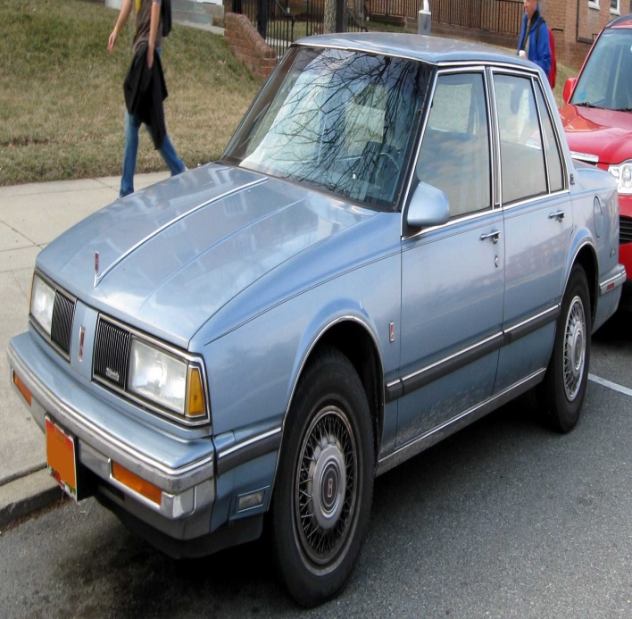](http://www.google.com/url?sa=i&rct=j&q=delta+88+oldsmobile&source=images&cd=&cad=rja&docid=vEKu-fape2GecM&tbnid=1HB0uDVi3eVJTM:&ved=0CAUQjRw&url=http%3A%2F%2Fcommons.wikimedia.org%2Fwiki%2FFile%3A86-88_Oldsmobile_Delta_88.jpg&ei=LSV4UZ6BIobVqgGcjoHAAQ&bvm=bv.45580626,d.aWM&psig=AFQjCNHt8Ub4HrTpazcfDiNsh9aD1d9pnA&ust=1366914704193295)