Chapter 10: The Jefferson Era

Lesson 1 | Lesson 2 | Lesson 3 | Lesson 4
A New Party in Power | The Louisiana Purchase | A Time of Conflict | The War of 1812
For up to the minute class information, text @ushirhi to 317-682-0984
Monday | Tuesday | Wednesday | Thursday | Friday
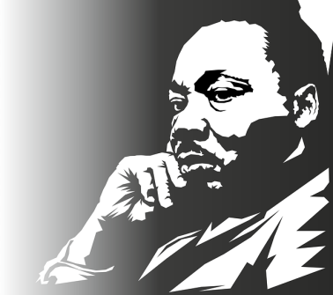 | 16 | 17 | 18 | 19
 | 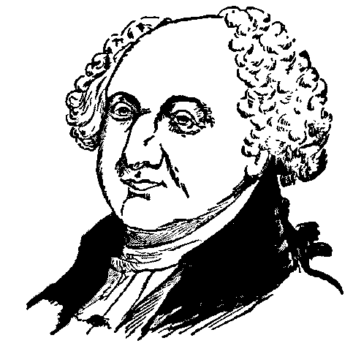  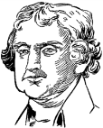  Election of 1800 | -Judiciary Act of 1801  -Supreme Court | -Move West  -The French?! | 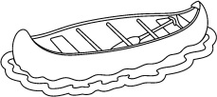  Lewis & Clark Expedition
 | HW: 10.1 Notes |  | HW: 10.2 Notes
22 Reading Day | 23 | 24 | 25 | 26
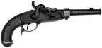  Hamilton  vs. Burr | 10.1-10.2 Quiz | -War at Sea  -Problems with Trade | Fighting Native Americans | War Hawks  And so it Begins…
HW: 10.1-10.2 SG | HW: 10.3 Notes |  | HW: 10.4 Notes
29 Reading Day | 30 | 31 | 1 | 2
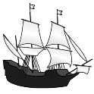  In the Navy | The War Concludes | Chapter 10 Review | Chapter 10 Test
 | HW: Study Guide
Class website: http://gms-history-rhinehart.weebly.com/ Quizlet: GMSHistoryRhinehart
People | Places | Vocabulary | Terms
John Adams  Charles Pinckney  Thomas Jefferson  Aaron Burr  John Marshall  James Madison  William Marbury  Napoleon Bonaparte  Robert Livingston  Toussaint L’Ouverture  James Monore  Meriwther Lewis  William Clark  York  Sacagawea  Zebulon Pike  Alexander Hamilton  Stephan Decatur  Tecumseh  Tenskwatawa/Prophet  William Henry Harrison  Gen. William Hull  Oliver Hazard Perry  Francis Scott Key  Andrew Jackson | Maryland  Mississippi River  New Orleans  Rocky Mts.  Kentucky  Tennessee  Santo Domingo/Haiti  Pacific Ocean  Grand/Pikes Peak  New Jersey  China/India/South America/Africa  Mediterranean Sea  Morocco/Algiers/Tripoli/ Tunis  Ohio River valley  Prophetstown, IN  Lake Erie  Chesapeake Bay  Baltimore  Ft. McHenry | inauguration  custom duties  jurisdiction  conestoga  secede  tribute  neutral rights  embargo  nationalism  frigates | Electoral College  Judiciary Act of 1801  Midnight Appointments  Marbury vs. Madison  Louisiana Territory  Northern Confederacy  Barbary pirates  Philadelphia  Leopard  Chesapeake  Battle of Tippeconoe  War Hawks  “Mr. Madison’s War”  Battle of the Thames  Treaty of Ghent  Battle of New Orleans

